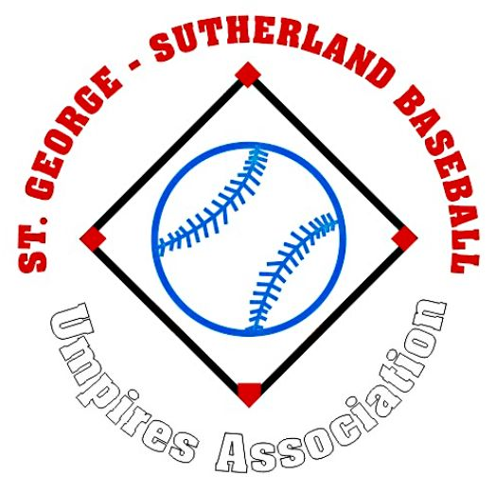
2008 Minutes

Date: Tuesday, 27th October 2008
Time: 7.34pm – 7.56pm

Apologies: Daniel Smith, Bruce Gordon, Geoff Ollerton, Phil Griffiths, Ray Wurlod.
Attendees: M. Williams, D. Cooper, A. Smith, D. Crabtree, C. Crabtree, K. Gallagher, C. Hodge, J. Staniforth,
G. Grigg, L. Petrucco, D. Kennedy, R. Barrington, K. Hemphill, G. Ashton, P. Barrington, R. Buggie, J. McDonald, S. Collins.

Correspondence Out: Notification of incident, Response by Executive addressing the incident

Correspondence In: 2 incident reports, Response to incident

Secretary Report: (S. Collins): (moved by D. Crabtree seconded by D. Cooper)
Follow up each member to find out if they approve of their e-mail and contact number being sent out to STG-SBUA members.

Send NSWBUA affiliation payment and list of STG-SBUA member names.

Treasurer Report (J. McDonald): (moved by M. Williams seconded by K. Gallagher)
Balance: $3604.85

Vice President: (G. Ashton): NIL

President Report: (R. Buggie): NIL

NSW Delegate – No Attendance
CSJBA Delegate – No update
CSMLBI Delegate – No meeting has been held
General Business:

P. Barrington:
- Raised an issue of an individual wearing a STG-SBUA umpires shirt and their appearance was untidy… wanted to know if the individual was registered with the STG-SBUA.
- Response from Colin Hodge was he loaned his shirt to the St Pats junior umpire.

M. Williams:
- Asked what the policy on uniforms were seeing that it was now after Round 5
- Response was to note it down on the Result Sheet and the CSMLBI Exec. will deal with it.

G. Ashton:
- Advised members of a situation of the Infield Fly Rule that was incorrectly applied by an umpire.

Next Meeting:
7.30pm, Tuesday 25th November 2008 at Comets Clubhouse

