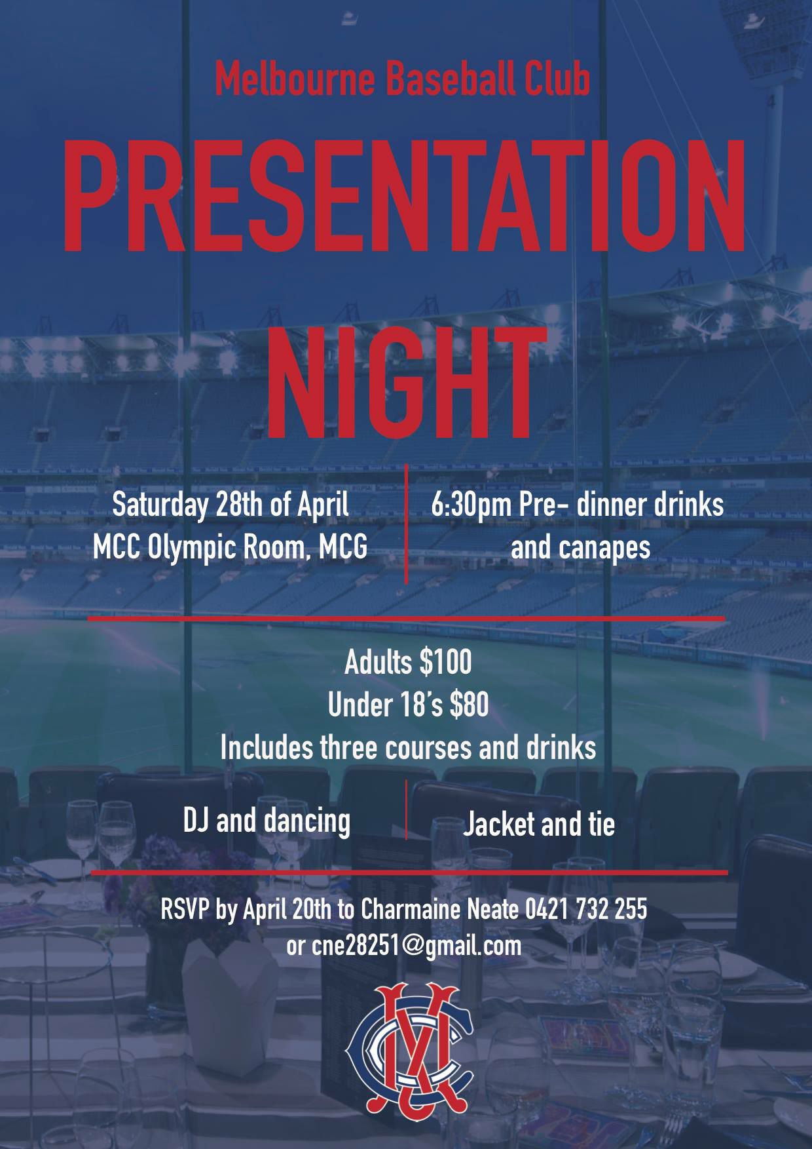
PAYMENT MUST BE MADE PRIOR TO THE NIGHT BY ONE OF THE FOLLOWING METHODS:
Credit card - Complete payment form attached and email to the treasurer
EFT - 083153 027888847
Cheque - Treasurer
MCC Baseball Section
PO Box 30
BOX HILL VIC 3128

Please return completed form to
Charmaine Neate at cne28251@gmail.com
or
MCC Baseball Section, PO Box 30, BOX HILL VIC 3128

PRESENTATION NIGHT SEASON 2017/18
ATTENDANCE FORM

Name of attendees:
Any special dietary requirements:
Carpark required: | Yes No

To assist with your preferred seating allocation, please circle the group below that best relates to you:
Non Players | Womens |  |  | Masters
Mens 1 | Mens 2 |  |  | Mens 3 |  | Mens 4 |  | Mens 5
Additional seating information:

PRESENTATION NIGHT SEASON 2017/18
CREDIT CARD PAYMENT FORM

TICKETS | QUANTITY | TICKET COST | TOTAL COST
Presentation Night – Adult |  | $100 | $
Presentation Night – 12 to 18 Year Old |  | $80 | $
Total Payable |  |  | $

CREDIT CARD DETAILS
Visa or Mastercard:
Expiry: |  |  | /
Signature:
Email Address:
Mobile:

