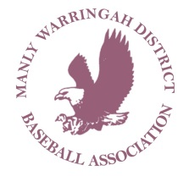
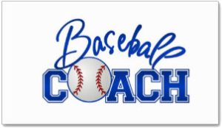

2016-17 ALL STAR MANAGER
(HEAD COACH) APPLICATIONS OPEN
Applications are open for All Star Manager (Head Coach) for the upcoming Little League, Junior League & Senior League State titles and progressional tournaments – to be received by COB 4 November to manlyjuniorreps@gmail.com.

NAME (in full):
PHONE:
DIVISION: Please highlight/circle or tick

SENIOR LEAUGE
JUNIOR LEAGUE
LL MAJORS
LL MINORS
COACHING ACCREDITATION: Please highlight/circle or tick

Level 1
Level 2
Level 3
Level 4

WWC Number:
Expiry Date:
DOB:
Address:

Junior Club Affiliation:

Junior Team Afflication:

COACHING EXPERIENCE:

Signed:

Dated:

