GREEN AND GOLD CLUB 2014
Michelle Kennedy; Nikki Beaton; Jenny Kiel; Robyn Bannerman
Michelle Kennedy – Player
10 Representations 2004 - 2014
2004 – Trans Tasman – Wellington NZ – 35’s team
2004 – IMHT – Kuala Lumpur – 35’s team
2005 – IMHT – Melbourne – 35’s team
2006 – Trans Tasman – Hobart – 35’s team
2007 – IMHT – Birmingham – England – 35’s team
2011 – International Invitational – Gold Coast – 40’s team
2012 – Oceania Development Tour – Fiji – 45’s team
2013 – Trans Tasman – Auckland – 45’s team
2013 – European Masters Cup – Belfast – 40’s team
2014 – Oceania Development Tour – 45’s team

Nikki Beaton (NSW) – Umpire and Coach
10 Representations 1996 - 2014
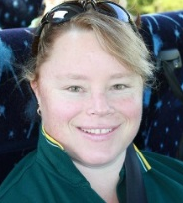
1996 – IMHT – Hong Kong – Umpire
2002 – Trans Tasman – Brisbane – Umpire
2003 – IMHT – Auckland – 35’s Coach
2005 – IMHT – Melbourne – 35’s Assistant Coach
2006 – Trans Tasman – Hobart – 40’s Coach
2008 – Trans Tasman – Hamilton NZ – Assistant Coach 50’s
2010 – Trans Tasman – Newcastle – 35’s Coach
2010 – Champions Cup – Nottingham – 45’s Assistant Coach
2013 – Trans Tasman – Auckland NZ – 45’s Coach
2014 – World Cup – Netherlands – 50’s Coach

Jenny Kiel (SA) – Player
10 Representations 2002 – 2014
2002 – Trans Tasman – Brisbane – 45’s team
2004 – Trans Tasman – Wellington NZ -45’s team
2006 – Trans Tasman – Hobart – 45’s team
2007 - IMHT – Birmingham England – 45’s team
2008 – Trans Tasman – Hamilton NZ – 45’s team
2009 - 50’s/55’s Tri series v NZ – Auckland – 50’s team
2010 – Trans Tasman – Newcastle -50’s team
2011 – International Invitational – Gold Coast – 50’s team
2013 – Trans Tasman – Auckland – 50’s team
2014 – England Tour – Aldershot– 55’s team

Robyn Bannerman (VIC) – Umpire Manager
10 Representations 2008 – 2014
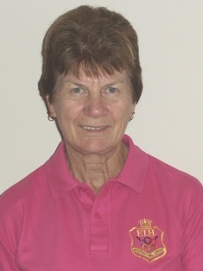
2008 – Trans Tasman – Hamilton NZ – Umpire Manager
2009 - 50’s/55’s Tri series v NZ – Auckland – Umpire Manager
2010 – Trans Tasman – Newcastle –Umpire Manager
2011 – International Invitational – Gold Coast – Umpire Manager
2012 - Oceania Development Tour – Fiji – Umpire Manager
2012 – Masters World Cup – Canterbury England – Umpire Manager
2013 – Trans Tasman – Auckland – Umpire Manager
2013 - European Cup – Belfast – Umpire Manager
2014 – England Tour – Aldershot– Umpire Manager
2014 - Masters World Cup – Netherlands – Umpire Manager

