Southern Metropolitan Cross Country Course Map – Ballam Park 2011

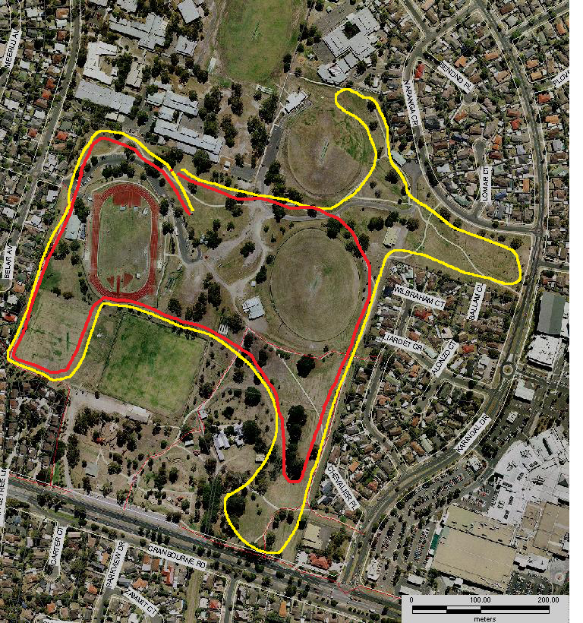
START
No 7
LEGEND
YELLOW LINE = 3KM COURSE
RED LINE = 2KM COURSE AND 5KM EXTENSION
No 14
No 13
No 12
No 11
No 10
No 9
No 8
No 6
No 5
No 4
No 3
No 2
No 1
FINISH

