BARWON SOUTH WEST
TENNIS CHAMPIONSHIPS
2011
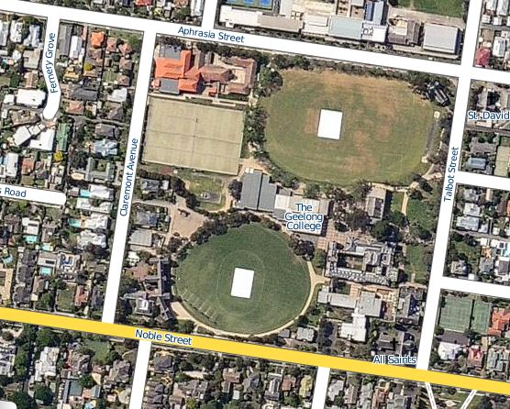

The Geelong College
138 Noble St, Newtown
Melways Ref: Map 451 G5
Friday 25th March
11am start (10.30am arrival)

Structure of the Barwon South West Region Tennis Championships

Sports

- Boys Tennis Championships
- Girls Tennis Championships

Location of Courts

- Entrance to courts and parking off Claremont Ave, Newtown
- Additional parking in Noble Street or Aphrasia Street

Nearest Milkbar
- Cnr of Aphrasia Street and Talbot Street Newtown. (200m walk)

Toilets

- The toilets for boys and girls are located in the leisure centre, swimming pool.

College Grounds

- Geelong College grounds have been specifically manicured for the purposes of the BSW Tennis Championships. It would be extremely helpful if all children ensured they picked up all their rubbish and took it with them or placed it in rubbish bins.

Registration Area

- The registration for the championships will be at the tennis courts.
- The registration fee is $10 per player.
- After children have registered they are free to have a warm up.
- A general assembly will be called prior to the start of play at 11am.
- Registration will close 15 minutes prior to the commencement of the program.

Parking

- There is ample street parking around the Geelong College.

Structure of Play

- Teams will be placed into 4 pools consisting of 3 teams each.
- The winning team in each pool will advance to a semi-final.
- The winning team in each semi-final will advance to the Grand-final
- The #1 ranked player of each team will play each other and the #2 ranked player of each team will play each other in singles matches
- Singles matches will play to 4 games, with a tie break at 3 all and sudden death deuce
- The overall winning Boys team and Girls team will proceed to Conference event
- Successful teams will be provided with information regarding the Conference event

Timetable of Regional Championships

TIME | ROUND | PLAYING TEAMS
11am | 1 | 1v2 3v4
11.45am | 2 | 2v3 1v4
12.30pm | 3 | 1v3 2v4
1.15pm | Grand Final  Boys  Girls | Winner of Pool 1 v Winner of Pool 2  Winner of Pool 3 v Winner of Pool 4

Pool 1 Boys Tennis Teams-  Court 1 &2  - Bellarine Division Runner Up Team  - Geelong North Winning Team  - Warrnambool Winning Team  - Colac Division Runner Up Team | Pool 2 Boys Tennis Teams-  Court 3 & 4  - Bellarine Division Winning Team  - Geelong North Runner Up Team  - Warrnambool Runner Up Team  - Colac Division Winning Team
*Exact team names will be determined when once division championships have been completed.

Pool 3 Girls Tennis Teams-  Court 5 & 6  - Bellarine Division Runner Up Team  - Geelong North Winning Team  - Warrnambool Winning Team  - Colac Division Runner Up Team | Pool 4 Girls Tennis Teams-  Court 7 & 8  - Bellarine Division Winning Team  - Geelong North Runner Up Team  - Warrnambool Runner Up Team  - Colac Division Winning Team

*Exact team names will be determined once division championships have been completed.

Regional Fees

- BSW Region will collect a fee of $10 per child payable at registration.

Umpires

- All children are required to umpire themselves. Where a dispute erupts please seek the advice from the Regional Coordinator.

Smoking

- As we will be conducting these trials on Geelong College School grounds SMOKING IF PROHIBITED AT ALL TIMES. This is the case at all School Sport Australia Sporting events.

First Aid

- Teams are required to supply their own first aid equipment and supplies.

