Bunya Sports James Drysdale Recreation Reserve Jinker Track Bunya www.pinehillslightning.baseball.com.au

ghtning.baseball.com.au
April 2014

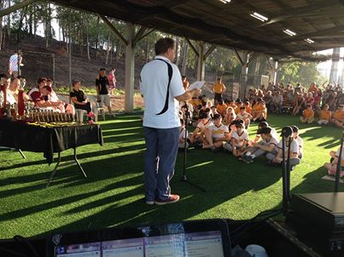

PRESIDENTS REPORT – 30 MAY 2014
Welcome and thank-you
This has been another successful year for Pine Hills Lightning Baseball Club and I would like to begin by thanking all the volunteers who stepped up last season to contribute to this success. It takes a dedicated effort to manage the activities of a club like ours.
- Management Committee – I would like to thank the members of the management committee who have toiled hard this year in their roles. The implementation of new management practices commenced this past season with the long-term goal to streamline the club’s management for a more sustainable future. Any change is difficult, and I would like to think that these new practices have been initially established, and with some fine-tuning will help the club going forward. Chris Lean, Louise Paewai and Jacqui Carseldine are stepping down from their committee roles after many years of service to the club. They will be greatly missed.
- Canteen Crew – Thanks to the canteen crew coordinated by Deonne Ehlerth. This is such a vital function for the club and we are fortunate to have the canteen managed so efficiently.
- Grounds Crew – Thanks to the grounds crew this season coordinated by Dave Giles. They have battled with the combination of dry spells, faulty sprinkler systems, new construction around the field etc. Thank you to Moreton Bay Regional Council who have recently re-turfed much of our playing surface on Diamond 1 and repaired some of those areas of field subsidence.
- Sound – Thank you to Peter Arnouts and Glen long for assistance with game day commentary and sound.
- Equipment - Thank you to Tim Carseldine for his management of equipment for teams, batting cages etc.

PINE HILLS BASEBALL 2013.14 YEAR BOOK

Vol. 1 Issue 1

PRESIDENTS REPORT cont’d
- Coordinators, Coaches, Managers, Scorers, Umpires – Thank you to our team volunteers comprising Coordinators, Coaches, Managers, Scorers and Umpires who all function to provide the right skills, information and environment to help players play the game to the best of their ability.
Little League Grand Finals
Pine Hills hosted both the Little League Grand Finals and an associated Rookie Ball Carnival this year and thank you to those volunteers who made these events, such a success.
Facility Upgrades
Seating Terraces – Thanks to Damian Toze, Mitch Paewai, Aaron Pearce and all the many volunteers who made this long standing project a reality. It was funded using profits from hosting the previous year’s senior grand final event.
Batting Cages - After several delays, this past season also saw the addition of new batting cages for the club. Thank you to the Department of National Parks, Recreation, Sport and Racing for the initial grant funding for this project and to the Moreton Bay Regional Council for their additional financial assistance. We also thank all those club volunteers who gave their time to make this project a reality. I think all will agree that these cages have been a very welcome addition to the club.
Projects for 2014 and beyond – The club has secured funding for an amenities block renovation which will commence shortly and continues to seek funding for new projects including new dugouts and a new canteen.
New Fields – Over the past 6 months, members of the committee have attended several meetings with MBRC as part of the planning process for new baseball fields that will be built in coming years. Stage 1 will see a new U14 sized field, located on the tip side of the current main diamond. We have been informed that funds for the detailed planning for this field should be available in the 2015/2016 budget with construction of the field to commence late in 2016. Additional fields are planned once the tip has been filled in the designated area.
Focus on Coaching: In the 2013 / 2014 season, the club continued its strong tradition of talented junior players being chosen for Metro, State and National representative teams Several senior players were also chosen for the Bandits and for US professional clubs. In order for the Pine Hills to continue to provide the appropriate environment for player development and therefore assist our players to achieve their team goals, there will be an additional focus on player and coach development in the 2014 / 2015 season.

PINE HILS LIGHTNING

PRESIDENTS REPORT cont’d
Volunteers
The Volunteer Rewards Program implemented by Pine Hills (along with an increasing number of Brisbane clubs) over the past two years, will continue this next season with some changes (to be advised shortly).
Pine Hills Baseball Club continues to run in a professional manner aiming to provide opportunities for baseball players of all ages. The club’s ability to deliver these opportunities as well as maintaining and improving its facilities relies primarily on the dedication of its volunteers. There is always a requirement for new volunteers to both carry on this proud tradition and to inject new ideas and new energy into the club community.
Please consider the skills you have and how you might be prepared to use these skills as a volunteer for the benefit of the Pine Hills players.
Graham VanKan

----------------------------------

We farewell Bob Nilsson: Bob came to coach our Majors at Pine Hills in 2010
He brought with him the experience of many years of playing and coaching.
In his second season with us he managed to get the club its first Majors Championship. The thrill was amazing. Each other season we were always somewhere in the top 5 but just not enough to end up in Grand Finals. For a young Majors club like ours this has been an amazing effort.
Bob continued to coach for the next 2 seasons but sadly to say he has decided it is time….time to walk away.
After a great journey he has decided to retire from coaching Majors.
We are sure Bob will stay involved with Pine Hills in some way however.

We welcome and thank Russell Teichmann who has taken on the role of Majors Coach. Russell came to our club a couple of seasons ago and immediately started to get involved. We knew right away that he would be a great club person and with this and his past experiences in NSW the committee have decided to give him a go coaching our Majors and providing guidance also to our other senior/u20 coaching staff in the 2014/15 season.

We again had great club numbers at the club this season with a combined total of 60 tee ball/rookie ball players. 4 teams of Little Leaguers, 3 teams of under 14’s, 2 teams of u16’s, 1 u20’s and 5 senior teams. Passing all the criteria we were again accepted into the Majors competition and due to our Majors running 5th after the seasons fixtures we will again be eligible for majors next season so long as we meet criteria.

Our club continues to grow and asks that all members get involved in a volunteer position to help the few become many. We must have more volunteers to reduce the load on those who have been so good to give so much of their time. Some for over 23 years!
We must not burn the volunteers out!
Paying fees is just to cover minimal costs, Volunteer efforts are needed by all that pay fees so that the fees can stay at a level that all can play this great sport.

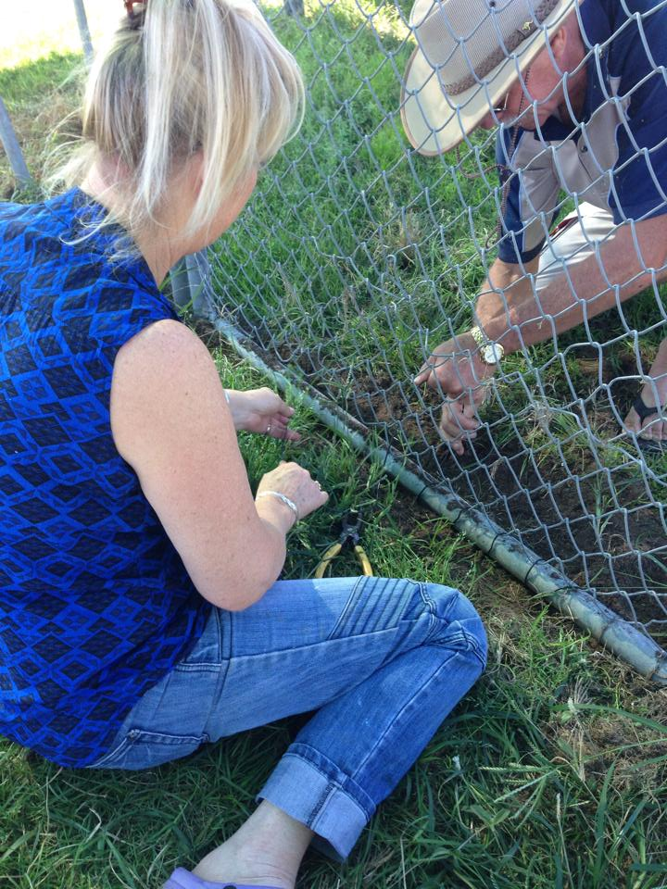

A huge thanks to Winston Witute for his outstanding efforts keeping the grounds mown and tidy. This man is an inspiration to all. Also to Lindsay Sutherland who has done our mowing for many seasons who has decided to retire. A huge thanks Lindsay
SPONSORS:
MAJOR CLUB SPONSORS.
Alderley Hire
Leading Edge Sports
Moreton Bay Regional Council
BJ Ball Paper
State Govt Gaming

Minor Club Sponsors
Home Run Financial Services
McDonalds Albany Creek.
Aspley Ten Pin Bowl
Baskin Robbins Albany creek. Rio Tinto

PINE HILLS LIGHTNING

TEAMS & COACHES.
Tball | Isotopes (Sat) | Russell Teichmann
Tball (Fri) | Muckdogs | Chris Ryder
Tball (Fri) | Muckdogs | Dan Taylor
Tball (Fri) | Mudcats | Mitch Gyles
Tball (Fri) | Mudcats | Nathan Toze
Tball (Fri) | Threshers | Mitch Hughson
Tball (Fri) | Threshers | Will Carseldine
Tball (Fri) | Crawdads | Jesse Farragher
Tball (Fri) | Crawdads | Jacqui Carseldine
Rookie Ball (Sat) | Demons (Sat) | Jason Calder &
Rookie Ball (Fri) | Demons (Sat) | Peter Roser
Rookie Ball (Fri) | Airhogs (Fri) | Matt Vellacott
Rookie Ball (Fri) | Thunder (Fri) | Paul MacHunter
Rookie Ball (Fri) | Chargers (Fri) | Peter Roser
Rookie Ball (Fri) | Scorpions (Fri) | Jason Calder
Little League Majors | Yankees | Craig McIver
Little League Minors | Orioles | Ross Field & Lex Smallhorne
Little League Minors | Dodgers | Dan Carseldine
Little League Minors | Brewers | Simon Tame
U14 Div1 | Cardinals | Terry Kilwinik
U14 Div2 | Pirates | Ross Dunn
U16 Div1 |  | Paul Hughson
U16 Div2 | Meteors | Michael Hipwood
U16 Div2 | Comets | Ron Youels
U20 |  | Matt Glasson
AA |  | Jared Long/Michael Formosa
AAA |  | Riki Paewai/Russell Teichmann
Major A |  | Bob Nilsson

2013.2014 Finalists Teams.
2013-2014 Teams into Finals
AAA
AA
Under 16 div 2
L/L Majors – 2013.14 Champions
L/L Minors Brewers

Management
- Graham Vankan – President
- Damian Toze –Vice President
- Jacqui Carseldine – Secretary
- Chris Lean – Treasurer / JDRR Rep
- Glenys Sutherland – Ass.Treasurer
- Louise Paewai – Sports Operations
Registrar
- Steve & Carol Cox
Junior Coaching co-ordinator
- Shannon Woodrow

Grounds Maitenance
- Winston Witute, Lindsay Sutherland, Michael Formosa Peter Ehlerth, Paul Stanford, David Gyles and Matt & Ryan Glasson
Schools Recruitment /Media
- Greg Long-
Grants/ Mr Music
- Peter Arnouts
Trophies/Ammenities
- Cathy Vellacott
Uniforms co-ordinator
- Rae Daley –
Other
- Lisa Taylor – Scorers
- Michael Blake – Umpires
- Glen Long – Seniors co-ordinator
- Tim & Dan Carseldine – Equipment
- Greg and Glen Long – Website/IT
- Damien Toze – Facilities Manager
Canteen
- Rae Daley, Deonne Ehlerth, Lesleigh Rodin, Jacqui Carseldine, Cathy Vellacott, Andrea Meade Helen Farragher, Christine Beattie
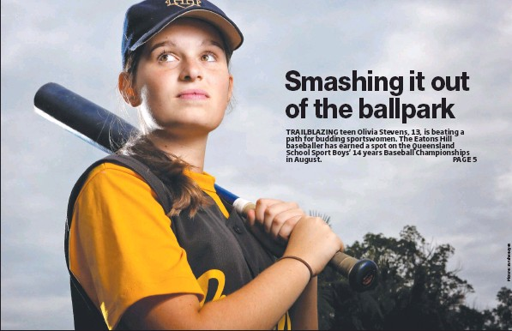
Volunteers - Representatives

Representatives
The 2014 Little League Metro Representatives:
Cameron Parry, Zac McIver and Sam Campion
2013 Metro U14 Team:
Ray Easton, Brock Preston and Ryan Woodrow

2013 Metro U16 Team:
William Carseldine - Mitchell Gyles – Mitchell Hughson
Jacob Nilsson - Nathan Toze - Nate Vankan -

2013 Metro Reps U18’s
Dan Carseldine, Jesse Farragher, Michael Greentree, Bryce Long, Jack Raverty, Matt Rodin, Alex Taylor, Hayden Timberlake.

2014 U25 METRO’s
Nic Bocchono (ass Coach), Josh Kurz, Bryce Long, Jack Raverty
Matthew Glasson (played for Wests)

RAMS Reps for 2014 Nationals

U18: Dan Carseldine, Hayden Timberlake
Jack Raverty (Territories)
U16: Nate Vankan, Jacob Nilsson
U15 Girls RAMS – Olivia Stevens
U14: Ray Easton

Australian U19 reps: Hayden Timberlake

Bandits Reps: David Sutherland, Jason Kilby, Mitch Nilsson, Casey Barnes and Craig Goodman

New Zealand Coaching Contract : Riki Paewai

Professional Signings:
Hayden Timberlake – Houston Astros
Sam Beattie – Scholarship Oklahoma Panhandle University

MLBAAP at Palm Meadows 2013 - Sam Beattie, Dan Carseldine, & Hayden Timberlake.

GBL AWARD Recipients: MVP AA Ryan McGill, U 20 Div 1 MVP Jack Raverty, Under 16 Div 2 ERA Lewis Sullivan, U16 Div 2 Batting Connor Lynch, u14 MVP Will Carseldine

QBUA LL Umpires Award - Tim Watkins

What big events happened in the 2013/14 season for Pine Hills:

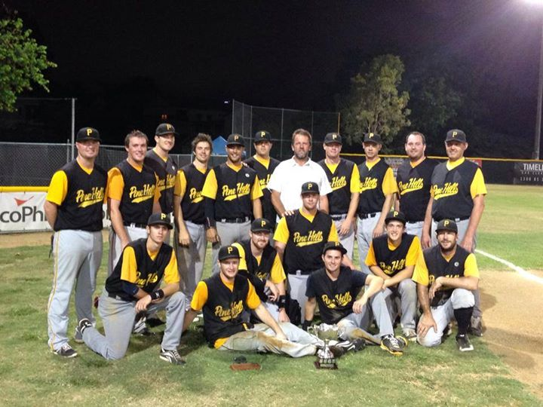
Pine Hills won the Paul Mutch Cup against rivals Windsor at Windsor 6-3.
Josh Roebig named Man of the Match winning the annual John Macan MVP Award.
The 10 years brings the games to five a piece.

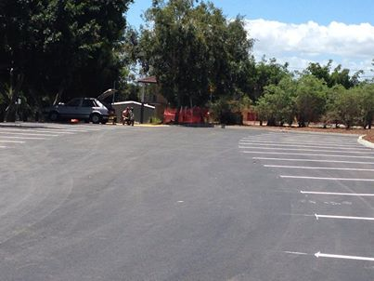
The top car park was sealed.

.
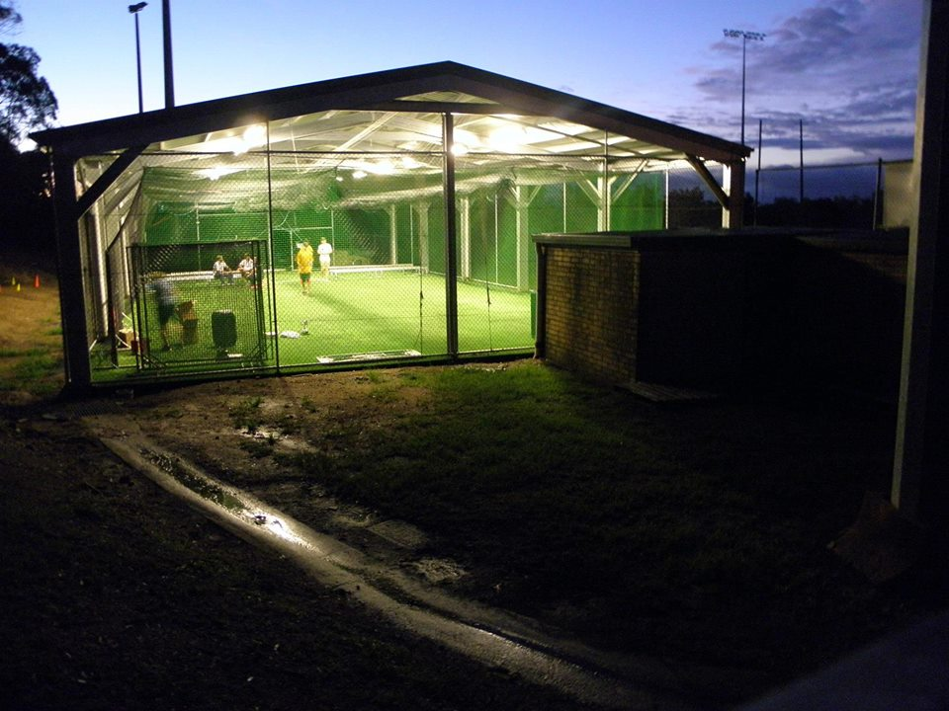
New Batting Cages were erected. Fantastic addition to the grounds at Pine Hills
which will come in handy for more than just batting in!
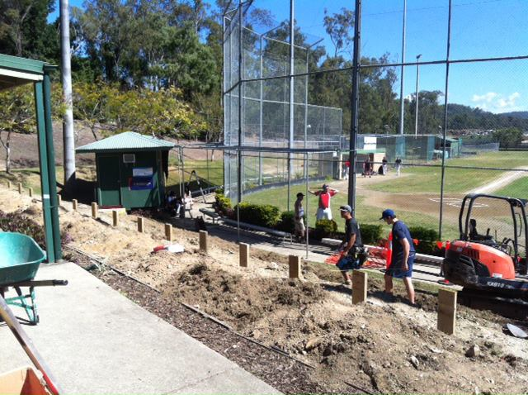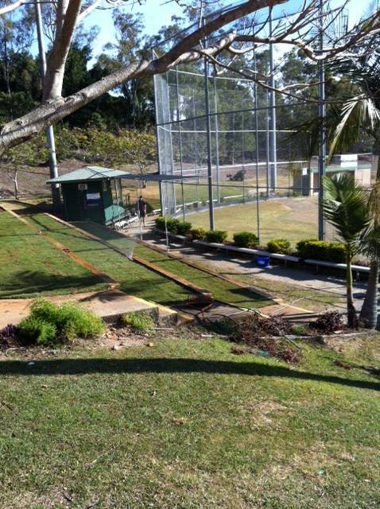

We had the terracing done and doesn’t it look great !

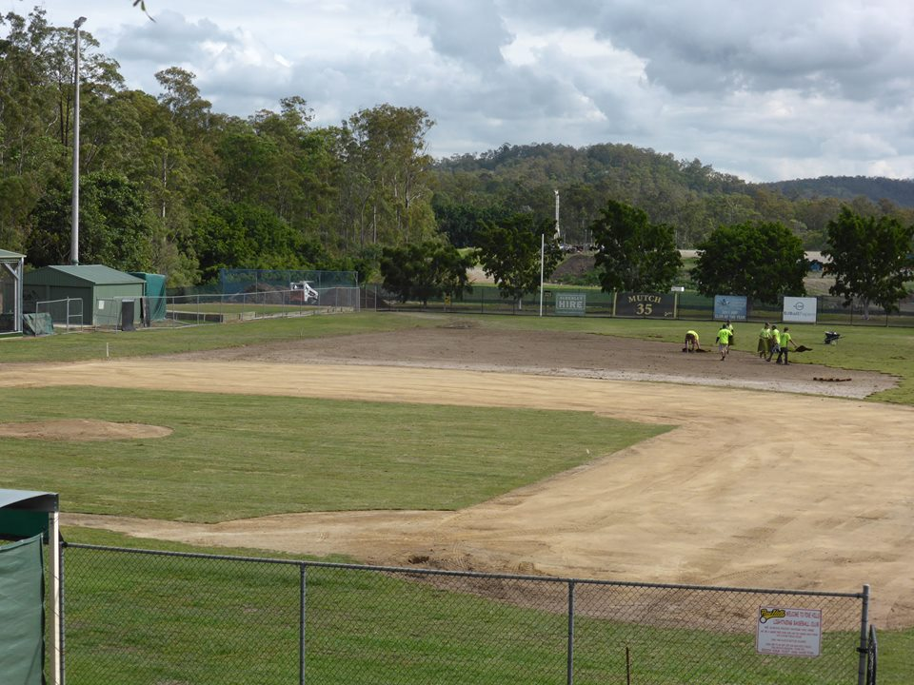
We introduced the Unicorn Cup game The top field was levelled and re turfed

2013.14 SERVICE MEDALS:

10 Year Service to Club
DALEY | Rae
LEAN | Chris
LONG | Glen
TOZE | Damien
15 Year Service to Club
GYLES | David
2013.14 CLUB PERPETUAL AWARDS:
The Most Valuable Club Person | Shannon Woodrow
Senior Encouragement for Dedication on and off the field | Matt Glasson & Michael Formosa
Junior Encouragement for Dedication on and off The Field | Jesse Farragher & Matt Vellicott
Coach's Encouragement Award | Ross Field

2013.14 SENIOR PERPETUAL AWARDS:

Batare Rookie of the Year | Dan Carseldine
Alderly Hire Club Pitching Award | Jack Raverty & Ryan Magill
Paewai's Best Team Person Award | Michael Formosa & Luke Thwaites
Ehlerth's Most Fly Catch's | Liam Bryan
Naughton's Club Catcher of the year | Ryan Thwaites & Nic Pokia
Thwaites's Most Improved Club Senior | Alex taylor
Peter Arnouts Senior/U20 RBI'S | Michael Formosa
Greg Longs Encouragement Award | Matt Vellicott

100 games
100 Games
Kilby | Jason
Nilsson | Jay
200 Games
Sutherland | David

Life members:
- Bruce & Sue Mutch
- Grahame Mitchell
- Willy and Louise Paewai
- Paul Thwaites
- Peter & Deonne Ehlerth
- Matt & Tania Naughton
- Peter Arnouts
- Greg Long
- Justin Cronin

GBL AWARD Recipients: MVP AA Ryan McGill, U20 Div div1 MVP Jack Raverty, Under 16 Div 2 ERA Lewis Sullivan, U16 Div 2 Batting Conor Lynch U14 MVP
Will Carseldine

2013.14 PLAYERS SERVICE MEDALS

5 Year Player
ANDERSON | JOSHUA
CHINN | JOHN
DUNN | HARRISON
GRANT | DYLAN
HALL | NICK
HERBERT | ADRIAN
KILIWNIK | THOMAS
KILIWNIK | LINDSEY
LEDWIDGE | JOSH
LYNCH | CONNOR
REID | DYLAN
ROBIN | SAMUEL
Sullivan | Lewis
WELLS | LIAM
WILLIAMS | KYFFIN
WOODROW | JEMMA
WOODROW | ALANNAH

10 year Player

DALEY | LACHLAN
TOZE | NATHAN
EDEN | JAMES
HINDOM | LAURIE
LONG | BRYCE
15 year Player
None
20 year Player
Thwaites | Luke

Honour Roll

Place Photo Here,
Otherwise Delete Box

Vol. 1 Issue 1

