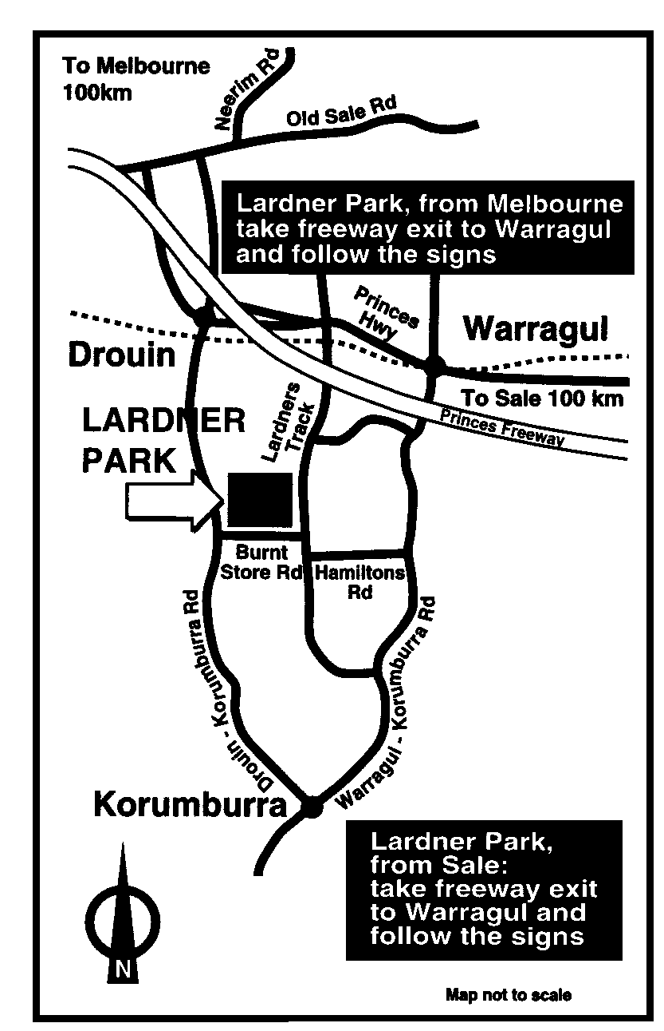

# LARDNER PARK – 3 km COURSE

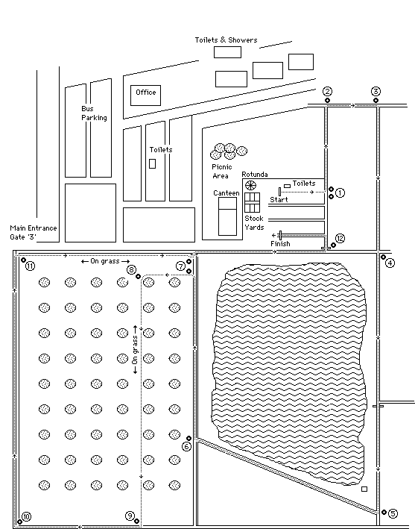

# LARDNER PARK – 5 km COURSE – SECOND LAP

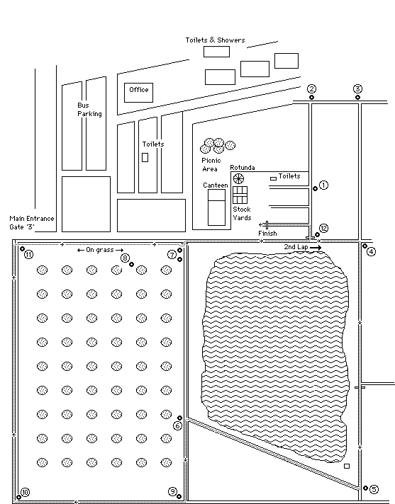

# LARDNER PARK – 2 km COURSE

